Labsheet-9
Mr. Kevin working as a cashier in ABC Retail Mart. You help him to generate bill of each item’s total price. Initially they stored all the products list in mysql database. Write a Java program to update total price of each item in mysql table and retrieve each product with total price and bill amount of a particular customer (ex. Cust1) from mysql using JDBC PreaparedStatement.
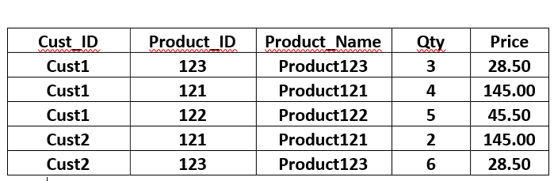

Solution:

import java.sql.*;
import java.util.Scanner;

public class SimpleRetailTotal {

public static void main(String[] args) {

String url = "jdbc:mysql://localhost:3306/test";
String user = "root";
String pass = "root123";

Scanner sc = new Scanner(System.in);

try {
Class.forName("com.mysql.cj.jdbc.Driver");
Connection con = DriverManager.getConnection(url, user, pass);

// -------- INSERT USING LOOP --------
String insert = "INSERT INTO retail (cust_id, product_id, product_name, qty, price) VALUES (?, ?, ?, ?, ?)";
PreparedStatement ps = con.prepareStatement(insert);

System.out.print("Enter number of records: ");
int n = sc.nextInt();

for (int i = 0; i < n; i++) {

System.out.println("\nEnter record " + (i + 1));

System.out.print("Customer ID: ");
ps.setString(1, sc.next());

System.out.print("Product ID: ");
ps.setInt(2, sc.nextInt());

System.out.print("Product Name: ");
ps.setString(3, sc.next());

System.out.print("Quantity: ");
ps.setInt(4, sc.nextInt());

System.out.print("Price: ");
ps.setDouble(5, sc.nextDouble());

ps.executeUpdate();
}

System.out.println("\nInserted Successfully!\n");

// -------- FETCH + TOTAL --------
String select = "SELECT * FROM retail WHERE cust_id = ?";
PreparedStatement ps2 = con.prepareStatement(select);

System.out.print("Enter Customer ID: ");
String cid = sc.next();

ps2.setString(1, cid);

ResultSet rs = ps2.executeQuery();

double totalBill = 0;

System.out.println("\nBill for " + cid);
System.out.println("---------------------------");

while (rs.next()) {

int qty = rs.getInt("qty");
double price = rs.getDouble("price");

double total = qty * price;
totalBill += total;

System.out.println(
rs.getString("product_name") +
" -> " + total
);
}

System.out.println("---------------------------");
System.out.println("Total Bill = " + totalBill);

con.close();

} catch (Exception e) {
e.printStackTrace();
}
}
}

Output:
Enter number of records:
3

Enter record 1
Customer ID: cust1
Product ID: 123
Product Name: Product123
Quantity: 2
Price: 28.50

Enter record 2
Customer ID: cust1
Product ID: 121
Product Name: Product121
Quantity: 4
Price: 145.00

Enter record 3
Customer ID: cust2
Product ID: 123
Product Name: Product123
Quantity: 6
Price: 148.60

Inserted Successfully!

Enter Customer ID: cust1

Bill for cust1
---------------------------
Product123 -> 57.0
Product121 -> 580.0
---------------------------
Total Bill = 637.0

